
Playing Offense with the “Citizen Playbook” #1
“Thought-Catcher”

This chart is designed simply to give you a place to capture your thoughts – not to fill in all the boxes. It’s a word document, so it can expand as needed and you can save your thoughts and come back to them. Just capture your top-of-mind thoughts and save the document. You can always refine or add actions.

- We act now - We do not wait – we choose to be “in the game” and not “on the sidelines”
- As “Citizens” we act from our “Larger Selves” - Even if we feel small, we “play large”, although we might start small and increase our actions as we gain experience
- We build on our strengths – we act on the strengths we have and build new strength as we go
- Support people are surprisingly important – and it only takes 2-3
- Actions may take us outside our “comfort zones” (just uncomfortable for a while – not damaging)
- These are really big strategies, so just add your specific actions even if they seem small

Citizen Playbook  Basic Strategies  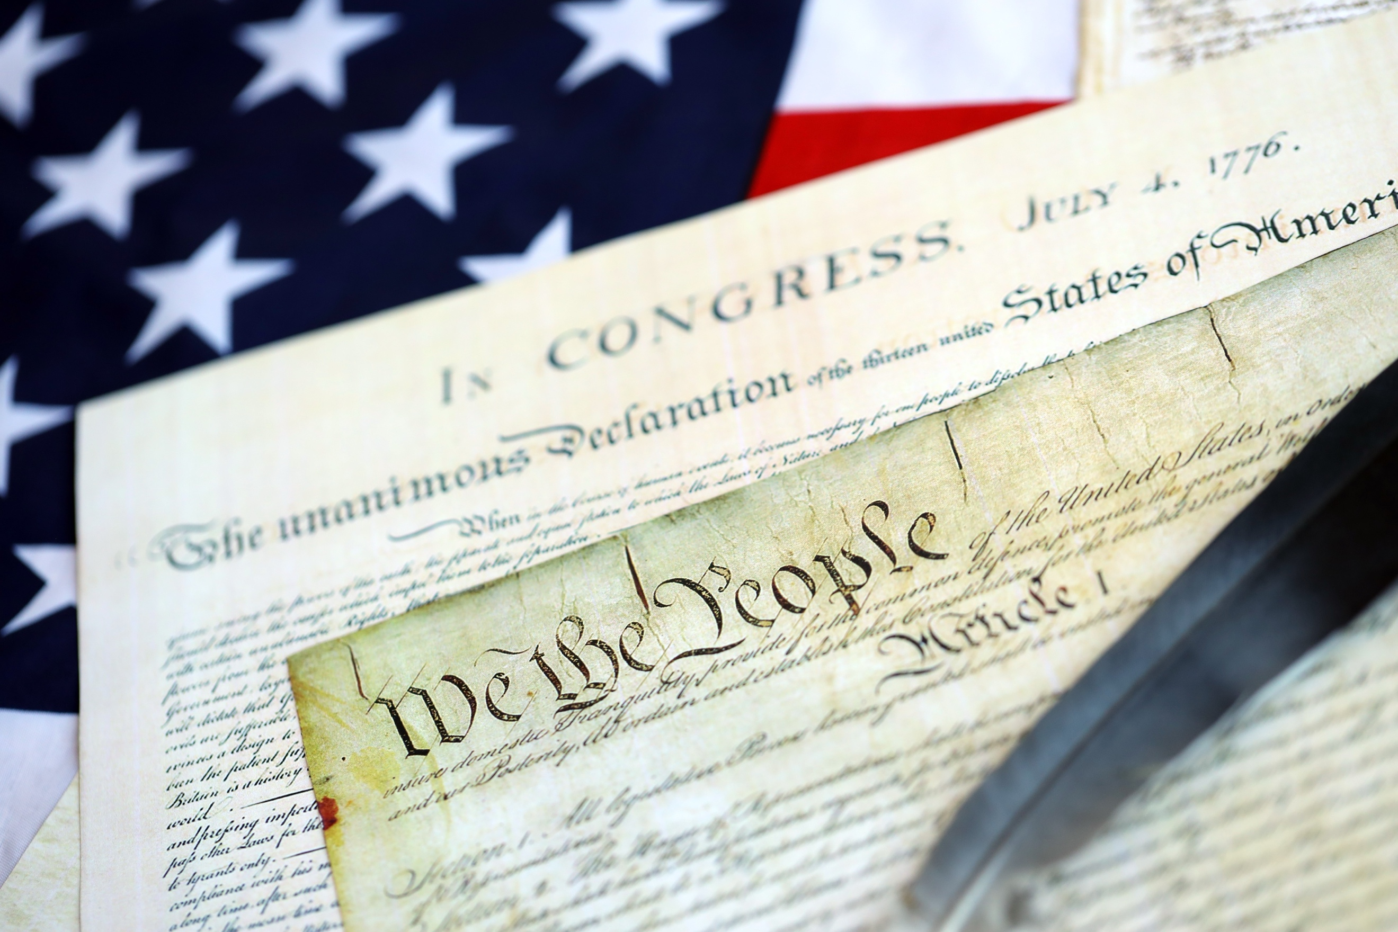 | My Actions (and when)   | Support People   | Notes
#1 We ensure free and fair elections

#2 We maintain and develop effective and credible branches of government

#3 We ensure a fair and just “rule of law”

#4 We protect a free press and a common understanding of “the truth”

#5 We manage a set of healthy “dynamic tensions”

#6 We hold elected officials, political appointees, and professionals in government agencies accountable

#7 We counter political and social polarization

#8 We counter political and social polarization

