
Playing Offense #2 – General Categories of Action
“Thought-Catcher”

This chart is designed simply to give you a place to capture your thoughts – not to fill in all the boxes. It’s a word document, so it can expand as needed and you can save your thoughts and come back to them. Just capture your top-of-mind thoughts and save the document. You can always refine or add actions.

- We act now - We do not wait – we choose to be “in the game” and not “on the sidelines”
- As “Citizens” we act from our “Larger Selves” - Even if we feel small, we “play large”, even if we start with smaller actions
- We build on our strengths – we act on the strengths we have and build new strength as we go
- Support people are surprisingly important – and it only takes 2-3
- Actions may take us outside our “comfort zones” (just uncomfortable for a while – not damaging)
- These are categories of actions from which to choose our specific actions

Citizen Action Category  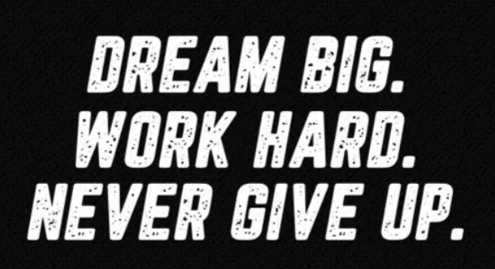 | My Actions (and when)  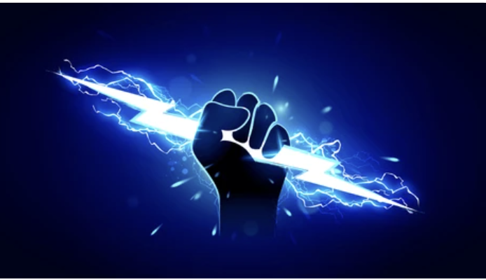 | Support People   | Notes
#1 We can make connections

#2 We can donate money

#3 We can
volunteer

#4 We can be a role model

#5 We can encourage others to act

#6 We can set or influence policy

#7 We can be part of the advocacy process

#8 We can protest peacefully

#9 We can hold officials and organizations accountable

#10 We can be active in civic organizations

#11 We can counter polarization and build solidarity

#12 We can be informed voters

#13 We can run for office

#14 We can support good government initiatives

