
Taking on the Big, Tough, Intimidating Issues We Face
“Thought-Catcher”

This chart is designed simply to give you a place to capture your thoughts – not to fill in all the boxes. It’s a word document, so it can expand as needed and you can save your thoughts and come back to them. Just capture your top-of-mind thoughts and save the document. You can always refine or add actions.

- We act now - We do not wait – we choose to be “in the game” and not “on the sidelines”
- As “Citizens” we act from our “Larger Selves” - Even if we feel small, we “play large” – even if starting with small actions
- We build on our strengths – we act on the strengths we have and build new strength as we go
- We venture outside our comfort zones where necessary – uncomfortable but rarely damaging
- Support people are surprisingly important – and it only takes 2-3

Tough Complex Intimidating Issues  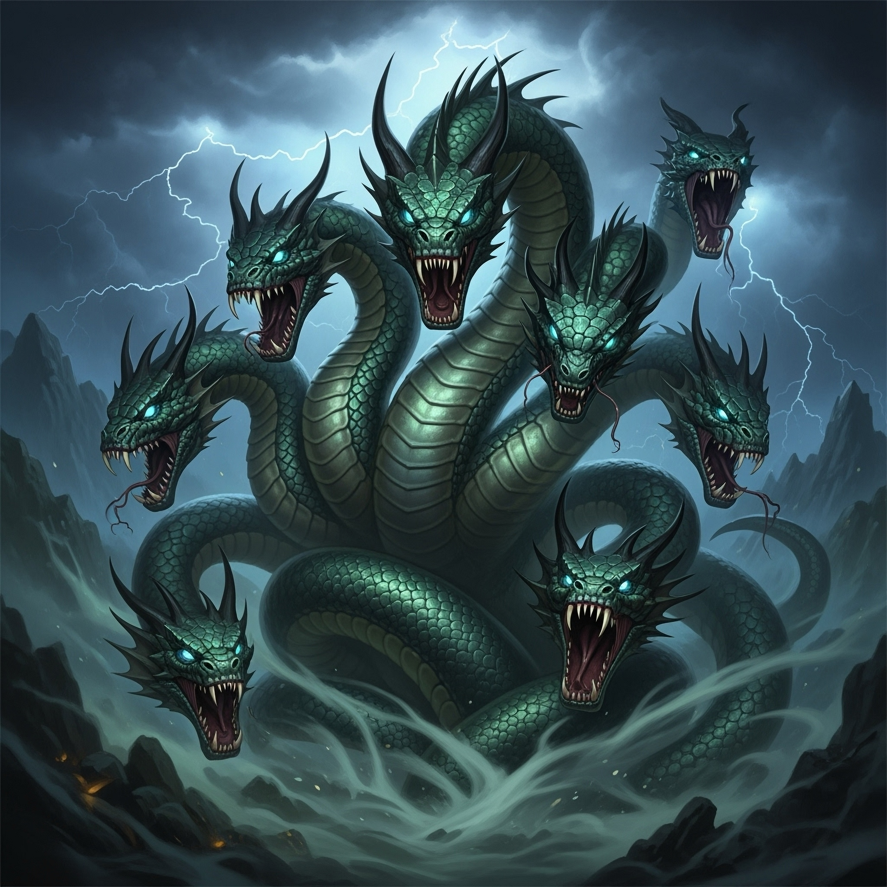 | My Actions (and when)  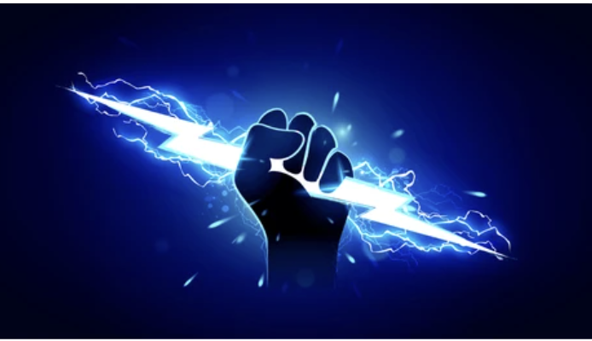 | Support People   | Notes
#1 We take on comprehensive immigration reform

#2 We take on the economic revitalization of rural America

#3 We take on closing wage and wealth disparities

#4 We continue to counter racism as well as recover from the consequences of our treatment of our native populations
institutions and processes

#5 We build our solidarity and minimize socio/political polarization

#6 We take on the challenges of rapidly developing AI and its impact

#7 We ensure the basics for people - food security, housing, equitable cost-effective healthcare, education, safe communities, etc.

#8 We respect our diversity of political and social beliefs and use it to creatively deal with the new challenges constantly thrown at us – together

#9 We take on climate change and deal with the various impacts

#10 We hold the line against terrorism and aggressive authoritarian regimes that threaten the America and the American experiment

